GEOLOGY 155 – Oceanography Lab

Spring Quarter 2004 (13757,SEC 6) INSTRUCTOR: SONJIA M. LEYVA
LAB: S. 11:45 AM – 1:25 PM OFFICE: PS 221, 323-343-2149
ROOM: PS-211 OFFICE HOURS: S. 1:30-2:00
WEBPAGE: www.calstatela.edu/faculty/sleyva EMAIL: SLEYVA@CALSTATELA.EDU

Text & Materials:
SYLLABUS And STUDY GUIDE FOR OCEANOGRAPHY FIELD LABORATORY –THE OCEANOGRAPHIC CRUISE ABOARD THE R.V. YELLOWFIN, Ivan P. Colburn. In addition to the text, bring a calculator, color pencils, and a ruler (combination metric/standard scale) to every lab session.

DATE | LAB TOPIC | PAGES | EXERCISE | DATE DUE
APRIL 03 | INTRODUCTION & BATHYMETRY | 1 – 9 | VIDEO
APRIL 10 | SOUTHERN CALIFORNIA BATHYMETRY  LIGHT PENETRATION IN THE SEA - WATER ZONES | 10 – 18  19 – 21 | 1 & 2 (p 60 – 67)  3 & 4 (p 68 – 71) | APRIL 17
APRIL 17 | SALINITY, DISSOLVED GASSES, ACIDITY, TEMPERATURE AND DENSITY, PLANKTON | 22 - 49 | DATA SHEETS (p 74 – 95)  Handout | APRIL 24
APRIL 24 | SEDIMENTS | 39 - 45 | 5 (p 72 – 73) | MAY 01
MAY 01 | QUIZ #1
 | BOAT TRIP! 12 AM |  | N: 75 - 95
MAY 08 | SHORELINE PROCESSES | 58 – 74 | HANDOUT | MAY 15
MAY 15 | SHORELINE PROCESSES | 58 – 74 | HANDOUT | MAY 22
MAY 22 | WAVES AND SEA CONDITIONS | 50 – 54 | HANDOUT | MAY 29
MAY 29 | QUIZ #2
 | BEACH TRIP! 7 AM
JUNE 05 | CALIFORNIA OCEAN CURRENT SURVEY | 55 - 58 | HANDOUT | JUNE 12
JUNE 12 | FINAL EXAM! 11:00 - 1:30 p.m.

Note: April 4th - Daylight Saving Begins

Class Attendance:
Students are expected to attend each laboratory period and to arrive on time. The laboratory period will start with a brief discussion on the techniques and concepts needed for the day’s laboratory assignment. Since it will not be possible to go over these materials more than once during the laboratory period, it is necessary for students to arrive on time. It will be difficult to make up missed laboratory periods. However, if you miss a laboratory period of valid reasons (illness), it will up to you to make arrangements to complete the lab exercise

Requirements:
LABS - A new laboratory assignment will be given for each laboratory period. The assignments will be due the following week at the beginning of class. Students are encouraged to work together in completing the laboratory work. However, each student should be sure to understand the techniques and concepts involved because midterm and final exam test problems will be very similar to laboratory problems. Labs are due the following week. Missed labs must be made up within two weeks or a grade of 0 (zero) will be given for the lab.

EXAMS - Two equally weighted quizzes are scheduled. The quizzes will be taken without cooperation between students. Labs will be reviewed in class and they must be completed by the assigned time.

FIELD TRIPS -- Attending the field trips is an absolute requirement. What we learn in class is geared to what we will observe during the field trips. Missing either of the field trips will result in you failing the course. In addition, students are required to complete and sign a waiver before attending the field trip. The waiver and a copy of your paid fee are required prior to the trip.

Grading:
Total possible class points will come from the exams and worksheets. The points scored on each exam and on the labs will be totaled and a percent determined for each student. A class grade will be assigned according to the following scale: A= 90%; B = 80-89%; C= 70-79% D= 60-69%; F=< 60%. Your grades will be available on the class website, www.calstatela.edu/faculty/sleyva/grades/index.html.

YOUR LAB GRADE IS WORTH ONE QUARTER (25%) AND YOUR LECTURE GRADE IS WORTH THREE QUARTERS (75%) OF YOUR OVERALL GENERAL GEOLOGY GRADE.

Important Policies:
Make-up exams will be given only to those who can verify a valid excuse for missing a quiz. The make-up will be given at a time that is mutually agreeable to both the student and myself, but must be arranged prior to the initial exam. Failure to take the make-up will result in the missed exam counting in as a zero.

University policy allows a grade of incomplete to be given only to those who have been sick, injured, or have a similar valid excuse. Incompletes will not be given after poor performance in the course.

If you are repeating any Cal State L.A. course in order to remove a D or an F from your transcript, you must file an academic renewal petition in Administration 101 no later than the last day to add a class. Instructions for doing this may be found under "Academic Renewal" in your Schedule of Classes.

Avoid the hassles. Take the Writing Proficiency Examination (WPE) after you have completed your English Composition and prior to the completion of 135 units in order to avoid a registration hold. The dates for the WPE are published in the Schedule of Classes. Enroll by registering in UNIV 400 and paying the $15 exam fee. Do it now!!!

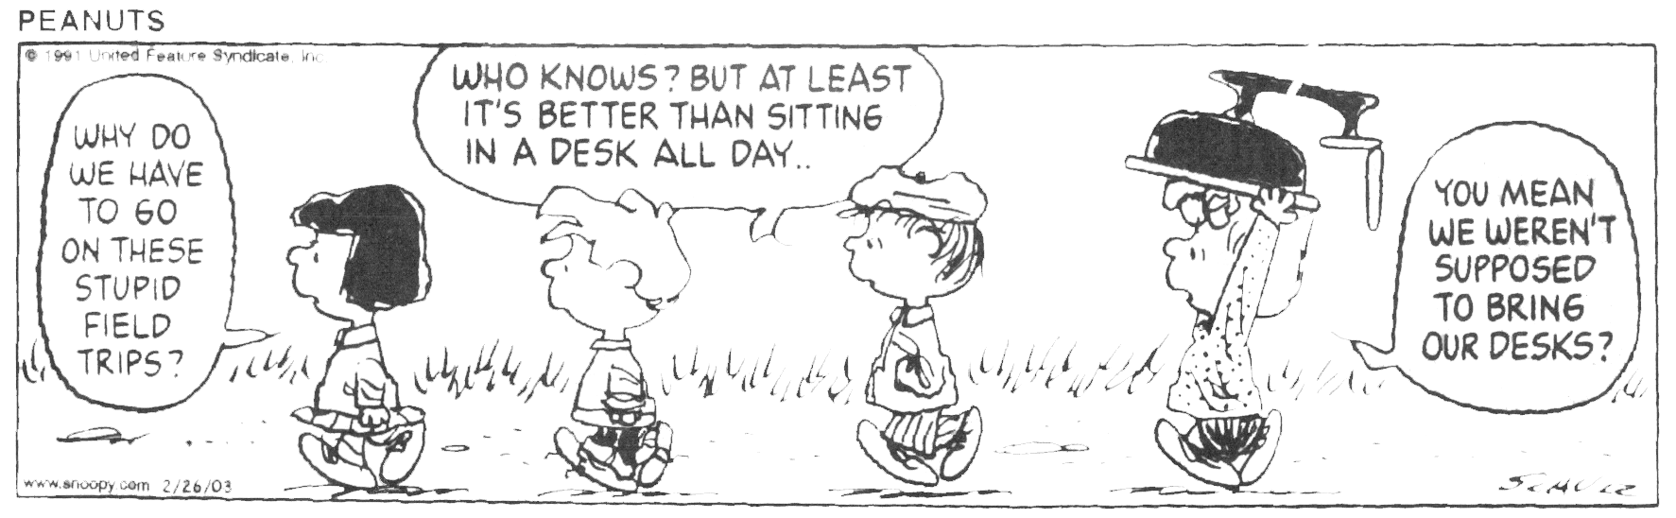
GEOLOGY 155 LAB - REPORT FORMAT

I. TITLE PAGE (incl. report title, name, date, course #, etc.)

II. INTRODUCTION
A. Location of Boat
B. Weather
C. Sea State
D. Objectives of the Cruise

III. BODY OF THE REPORT (minimum 4 typewritten, double-spaced pages)

A - Discussion of tools used
Use the cruise itinerary as your outline.
Tools used during Yellowfin Cruise (not in order)
1. Van Veen grab sampler (relict sediment from old beach)
2. Zooplankton net (500 micron mesh) for the plankton tow
3. YSI - (electronic collection of seawater data recorded on Hydrolab data sheet including pH, salinity, dissolved oxygen and temperature versus depth
4. Secchi disk (light penetration or turbidity)
5. Forel-Ule color comparator (seawater color)
6. XBT (expendable bathythermograph) (depth vs temp.)
7. Rock dredge (bottom collection of rocks and organisms)
8. Otter trawl (near bottom nekton)
9. GPS (location of sampling stations)
10. Refractometer (optical) (salinity verification)

B - Presentation of Data
1. Station 1- (deep water, San Pedro Submarine Cyn.)
2. Station 2- (shallow water, inside jetty)
3. Station 3 – LA River (if time permits)

C - Discussion of data
1. Comparison of both deep-water station and shallow water station with each other and with what is considered to be normal for the ocean.
2. Normals for the ocean- (all are surface measurements):
a. pH- ranges between 7.8 and 8.3
b. Temperature- avg. at surface approx. 17 degrees C
c. Dissolved oxygen - 6.5 ml/l
d. Salinity - 34.7 (parts/thousand)

IV- Conclusions (please make these scientific and not concerned with personal feelings (seasickness, being cold, etc.)

V- References Cited (Bibliography)

VI- Appendix
A. Original Data Sheets
B. Other Data
1. Photos (could be included in the text)
2. Graphs of numerical data (could be included in text)
3. Maps, plates, that cannot be included in the text

