Oceanography 155 Lab Syllabus

GEOLOGY 155 INSTRUCTOR: SONJIA M. LEYVA
OCEANOGRAPHY Lab (11304,SEC 4) OFFICE: 226 PHYSICAL SCIENCE BLDG.
LAB: Tues. 1:15 PM – 2:55 PM OFFICE HOURS: T: 12 – 1 PM, W: 10 – 11:30 AM
ROOM: PS-211 OFFICE TELEPHONE: 323-343-2412
WEBPAGE: www.calstatela.edu/faculty/sleyva EMAIL: SLEYVA@CALSTATELA.EDU

Text & Materials:
SYLLABUS and STUDY GUIDE FOR OCEANOGRAPHY FIELD LABORATORY –THE OCEANOGRAPHIC CRUISE ABOARD THE R.V. YELLOWFIN, Ivan P. Colburn. In addition to the text, bring a calculator, color pencils, and a ruler (combination metric/standard scale) to every lab session.

Description:
This course is structured around an oceanographic cruise on our Research Vessel Yellowfin. On the cruise you will work with the instruments that oceanographers use to gather their data and you will take and record data readings. After the cruise is over and we are back in the classroom, we will work together with the collected data to interpret it and to help you gain a better understanding of how the oceanographers use the data to evaluate the nature, condition, and workings of the ocean. Using this knowledge, you will be required to submit a report summarizing your data and findings.

Class Attendance:
Students are expected to attend each laboratory period and to arrive on time. The laboratory period will start with a brief discussion on the techniques and concepts needed for the day’s laboratory assignment. Since it will not be possible to go over these materials more than once during the laboratory period, it is necessary for students to arrive on time. It will be difficult to make up missed laboratory periods. However, if you miss a laboratory period of valid reasons (illness), it will up to you to make arrangements to complete the lab exercise

Requirements:
LABS - A new laboratory assignment will be given for each laboratory period. The assignments will be due the following week at the beginning of class. Students are encouraged to work together in completing the laboratory work. However, each student should be sure to understand the techniques and concepts involved because midterm and final exam test problems will be very similar to laboratory problems. Labs are due the following week. Missed labs must be made up within two weeks or a grade of 0 (zero) will be given for the lab.

EXAMS - Two equally weighted quizzes are scheduled. The quizzes will be taken without cooperation between students. Labs will be reviewed in class and they must be completed by the assigned time.

FIELD TRIPS -- Attending the field trips is an absolute requirement. What we learn in class is geared to what we will observe during the field trips. A report (4+ pages) based upon the data from the oceanographic cruise is also required. Missing either of the field trips will result in you failing the course.

The University charges a fee of $7.50 for the Yellowfin Cruise. This fee will cover the cost of the cruise only. Meals, for example, are not included. You must pay this fee at the Cashier’s office. In addition, students are required to complete and sign a waiver before attending the field trip. The waiver and a copy of your paid fee are required prior to the trip.

As a part of the class, students will write a report based upon their findings on the Yellowfin Cruise. An outline of what the report should contain is attached. The report will be graded on neatness, completeness of data, your interpretation of the data, grammar and spelling. The report is to be typed, double spaced, using either 10 or 12-point Arial or Times Roman font, and at least four pages in length.

Grading:
Total possible class points will come from the quizzes, field trip attendance, and lab assignments. The points scored on each exam and on the labs will be totaled and a percent determined for each student. A class grade will be assigned according to the following scale: A= >90%; B = 80-89%; C= 70-79% D= 60-69%; F=< 60%. Your grades will be available on the class website, www.calstatela.edu/faculty/sleyva.

YOUR LAB GRADE IS WORTH ONE QUARTER (25%) AND YOUR LECTURE GRADE IS WORTH THREE QUARTERS (75%) OF YOUR OVERALL OCEANOGRAPHY GRADE.

Oceanography 155 Lab

Course Schedule

DATE | LAB TOPIC | PAGES | EXERCISE | DATE DUE
6/24 | INTRODUCTION & BATHYMETRY | 1 – 9 | VIDEO
7/01 | SOUTHERN CALIFORNIA BATHYMETRY  LIGHT PENETRATION IN THE SEA - WATER ZONES | 10 – 18  19 – 21 | 1 & 2 (p 60 – 67)  3 & 4 (p 68 – 71) | 7/08
7/08 | SALT WATER & PLANKTON | 22 - 49 | DATA SHEETS (p 74 – 95)  Handout | 7/15
7/15 | SEDIMENTS | 39 - 45 | 5 (p 72 – 73) + handout | 7/22
7/22 | MIDTERM
7/26 | BOAT TRIP! 7 AM |  | N: 75 - 95 | REPORT: 8/26
7/29 | QUIZ & BOAT TRIP DISCUSSION | 58 – 74 | HANDOUT | 8/05
8/05 | SHORELINE PROCESSES | 58 – 74 | HANDOUT | 8/12
8/12 | WAVES AND SEA CONDITIONS | 50 – 54 | VIDEO & HANDOUT | 8/19
 | BEACH TRIP! 7 AM |  |  | 8/26
8/19 | BEACH TRIP DISCUSSION / CALIFORNIA OCEAN CURRENT SURVEY | 55 - 58 | HANDOUT | 8/26
8/26 | REVIEW
9/04 | FINAL EXAM! 1:30 - 4:00 p.m.

Important Policies:
Make-up exams will be given only to those who can verify a valid excuse for missing a quiz. The make-up will be given at a time that is mutually agreeable to both the student and myself, but must be arranged prior to the initial exam. Failure to take the make-up will result in the missed exam counting in as a zero.

University policy allows a grade of incomplete to be given only to those who have been sick, injured, or have a similar valid excuse. Incompletes will not be given after poor performance in the course.

If you are repeating any Cal State L.A. course in order to remove a D or an F from your transcript, you must file an academic renewal petition in Administration 101 no later than the last day to add a class. Instructions for doing this may be found under "Academic Renewal" in your Schedule of Classes.

Avoid the hassles. Take the Writing Proficiency Examination (WPE) after you have completed your English Composition and prior to the completion of 135 units in order to avoid a registration hold. The dates for the WPE are published in the Schedule of Classes. Enroll by registering in UNIV 400 and paying the $15 exam fee. Do it now!!!

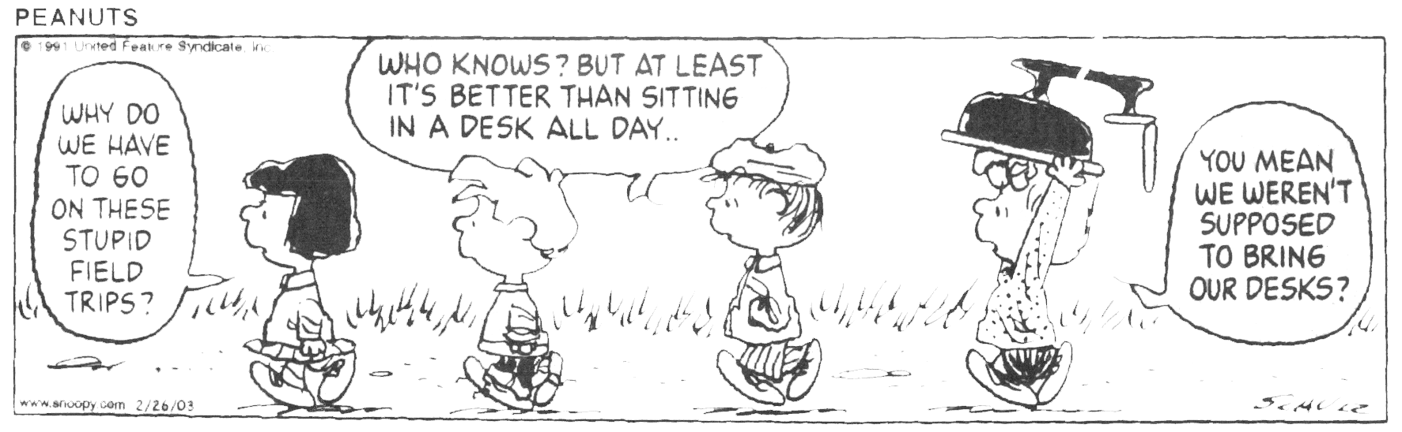
GEOLOGY 155 LAB - REPORT FORMAT

I. TITLE PAGE (incl. report title, name, date, course #, etc.)

II. TABLE OF CONTENTS

III. INTRODUCTION
A. Location of Boat
B. Weather
C. Sea State
D. Objectives of the Cruise

IV. BODY OF THE REPORT (minimum 4 typewritten, double-spaced pages)

A - Discussion of tools used. You may use the cruise itinerary as your outline. Discuss which tools were used and their function.
Tools that may be used during Yellowfin Cruise (not in order)
1. Van Veen grab sampler (relict sediment from old beach)
2. Zooplankton net (500 micron mesh) for the plankton tow
3. YSI - (electronic collection of seawater data recorded on Hydrolab data sheet)
4. Secchi disk (light penetration or turbidity)
5. Forel-Ule color comparator (seawater color)
6. XBT (expendable bathythermograph) (depth vs. temp.)
7. Rock dredge (bottom collection of rocks and organisms)
8. Otter trawl (for collecting near bottom nekton)
9. GPS (location of sampling stations)
10. Refractometer (optical) (salinity verification)

B - Presentation of Data. For each station, list the salinity, dissolved oxygen, pH, and temperature readings in table form. Don’t forget to include the bottom depth, the depth to which the Secchi disk penetrated, the Forel-Ule color, and the description of the sediment collected.
- Station 1 – Deep water, San Pedro Submarine Cyn.
- Station 2 – Relict Beach
- Station 3 – Inner Harbor
- Station 4 – Los Angeles River (if time permits)

C - Discussion of data. You will need to do three things in this section:
  - Discuss the data collected at each station.
  - Compare each station with the others.
  - Compare each station with the “normals” for the open ocean
    - Normals for the ocean- (all are surface measurements):
      - pH- ranges between 7.8 and 8.3
      - Temperature- avg. at surface approx. 17 degrees C
      - Dissolved oxygen - 5.5 ml/l
      - Salinity - ~35 (parts/thousand)

V- Conclusions. Please make these scientific and not concerned with personal feelings (seasickness, being cold, etc. Include any observations you might have regarding the data. For example, if the salinity was higher or lower than you might expect, why do you think it was that way?

VI- References Cited (Bibliography)

VII- Appendix
A. Original Data Sheets
B. Other Data
- Photos (could be included in the text)
- Graphs of numerical data (could be included in text)
- Maps, plates, that cannot be included in the text

GRADING: The report will be graded as follows: 50% the report itself & interpretations, 25% data sheets from cruise, and 25% grammar, spelling, neatness and presentation. A report folder is not necessary, but DO NOT hand in a report with loose pages (i.e., not stapled together.)

